What is Slope Rating?
Slope Rating is probably the most misunderstood element in the Handicap System. Please review the following graph, and explanation below.
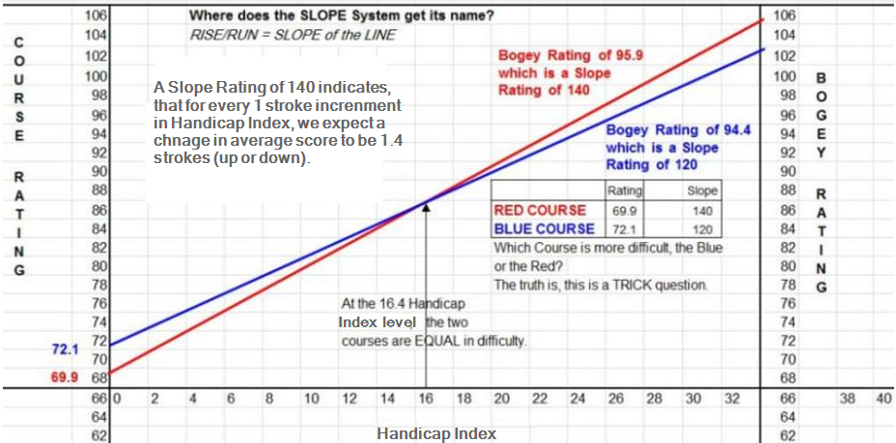
In the graph above, there are several concepts to grasp, but the main one is the relationship of Course Rating to Slope Rating/Bogey Rating. This is a good time to clear up the biggest misconception about Slope Rating, that a high slope rating means a more/very difficult golf course. That is not absolutely speaking a true statement. What is true; a high Slope Rating DOES NOT necessarily mean a more difficult golf course (this will be proved shortly). A high Slope Rating simply means we expect the scores of the scratch player and bogey player to be more spread out (a larger difference), than compared to a course with a lower Slope Rating. Slope alone is not the sole indicator of ABSOLUTE difficulty. The question above, "which course is more difficult", is a bit of a trick question. To determine difficulty we need to know three factors;
1) The Course Ratings of each course to compare,
2) The Slope Ratings (Bogey Rating), and
3) the caliber of player (Handicap Index) in reference to the first two items (Slope and Course Rating). The proof is in the graph, which we will now review.
As we know, Course Rating reflects the probable scores of scratch golfers (this could also be called the Scratch Players Target Score or what they need to shoot to play to a ZERO Course Handicap). A quick note, Scratch golfers DO NOT SHOOT/SCORE PAR, we expect them to actually shoot the COURSE RATING, Par and Course Rating are quite different. If a scratch player shoots 72 (which happens to be par of the course too) on a course with a Course Rating of 73.1 (ignoring slope for the moment), that scratch player just played to a +1.1 differential (even better than scratch). Refer to the example/graph, if we know that Course Rating reflects the probable scores of scratch golfers, and analyzing the Blue Course with a Course Rating of 72.1 VS the Red Course at 69.9, we can easily conclude the Blue Course is more difficult for the Scratch golfer (as we expect scratch golfers to average 2.2 strokes higher on the Blue Course).
Let's do the same analysis with the Bogey Golfer. We know that the Bogey Rating is the expected average score for these golfers (bogey golfers), knowing this and analyzing the results above, the Red Course has a Bogey Rating of 95.9 and the Blue Course has a Bogey Rating of 94.4. From this we can conclude the Red Course is more difficult for the Bogey golfer (as we expect bogey golfers to average 1.5 shots higher on the Red Course).
Finally, let's analyze what happens at the 16.4 Handicap Factor level. The Blue and Red Courses intersect on the graph; this is the point that indicates EQUAL difficulty (for that particular player on either course). It doesn't matter which course this player plays, we would expect the same scoring result (on average).
The Blue Course is more difficult for Scratch golfers, while the Red Course is more difficult for Bogey golfers. How is this possible? These are two completely different players, who hit the ball in much different locations with different accuracy. If you think about what obstacles may or may not exist in their landing zones (where they normally would play from), it’s easy to see what impact these features may have on that players scoring ability. For example, perhaps on the Blue Course more obstacles (even length) exist in the zones of the Scratch golfer in comparison to that of the Red Course, this is likely the reason the Course Rating (expected scores) are so different, making it harder for the scratch player to score well on the Blue Course in comparison to the Red Course. The same could be said of the Red Course for the Bogey golfer as compared to the Blue Course. It’s likely more obstacles, and/or length exists for the Bogey golfer on the Red Course, in comparison to the Blue Course for their play.
You can now clearly see why Slope Rating is not the only (absolute) factor to consider when trying to determine the difficulty of a golf course. A high Slope Rating simply means that we expect the scores of the Scratch golfer VS the Bogey golfer from that particular tee to be a larger spread than compared to a course with a lower Slope Rating. A Slope Rating of 140 for example, simply means that for every 1 stroke increment in Handicap Index, we expect scores to change by 1.4 strokes!
The next question usually is; why introduce Slope Rating? Slope Rating was introduced to simplify the conversion process for the start of the Course Handicap calculation, it draws a relationship of the scratch and bogey golfer. And by extension all other golfers, any ability (PLUS golfers, high and mid handicappers alike). We calculate the relationship (Slope of the line = RISE / RUN) between scratch and bogey players from that particular tee to predict the scores of all golfers, and give them an associated Course Handicap start from that tee. That is the brilliance in the SLOPE SYSTEM.

